Krysana Maragh
Distracted Drives Education
Linear View of Civic Engagement Project
Driving is a privilege. Safety is a right. Both are taken for granted far too often. It’s commonly agreed that driving under the influence is bad and should be outlawed. But we’re ignoring the drug of choice for the 21st Century: our cell phones. It always takes a while for the law to catch up with technology but after 15 years we don’t seem to have the solution. In fact, we’re making the problem worse with designs like voice-text applications and cars designed with Wi-Fi capabilities. In the fight for attention on the roadways, it seems our attention is too often drawn in dangerous directions. Distracted Driving is a major issue, but it can be combated.
Distracted Driving is defined by the CDC as driving while doing any activity that takes your attention away from driving. This includes using a cell-phone, texting, and eating. But these examples only encompass the manual category of distraction. What many drivers fail to realize is there exist far more distractions than these that have the potential to endanger lives. Even the use of in-vehicle technologies such as radio and navigation can be a source of distraction. The three main categories include visual, manual, and cognitive. Texting is especially threatening because it combines all three! (CDC). Visual Distractions are defined as the driver taking his/her eyes off the road; includes reading billboards, maps, text messages, and any act of turning ones eye away from the road for extended periods of time. Manual Distractions are defined as the driver removing his/her hands from the steering wheel; includes fiddling with the radio and navigation systems, food, and/ or phone applications such as composing a text message. Cognitive Distractions are defined as the driver taking his/her mind off of driving. Focus is the main key to safe driving; any act that captures the drivers’ attention can be deemed a cognitive distraction. (CDC).
The CDC reported that in 201l, about one in every five car crashes in which someone was injured involved distracted driving (CDC). to the US Department for Transportation, in 2013 alone 32,719 deaths were attributed to motor vehicle related incidents. Nearly 10% of these deaths resulted from distracted driving crashes (Distraction.gov). Of the top related reasons of all time for fatality distracted driving ranked third at an overwhelming 26% (NSC). The national Safety Council remarks, “With advancements in cell phone technology, distracted driving has been an increasing and misunderstood trend,” (NSC). Thirty years ago this definition of this category would be far less technology based but the fact remains that today’s drivers are facing risks previously unheard of and not easily combated.
The growth and advancement on technology proves to be of the biggest concerns for driving safety. The AAA Foundation for Traffic Safety found in a recent study aimed at measuring cognitive distraction in automobiles that the latest hands-free technologies are substantially more hazardous than helpful. AAA CEO and Foundation President Peter Kissinger stated on record, “Increased mental workload and cognitive distractions can lead to a type of tunnel vision or inattention blindness where motorists don’t see potential hazards right in front of them,” (White, 2013). AAA released their findings in June 2013 and it was remarked as, “the most comprehensive study of it’s time to look at the mental distraction of drivers,” (White, 2013). Drivers were asked to engaged in common tasks while behind the wheel such as talking on the phone (both handheld and hands-free), listening to music/audio books, and responding to voice-activated emails. After the series of audio and visual tests were performed, levels of mental distraction were ranked on a scale 1-3 (minimal to greatest). Passive audio tasks such as listening to the radio ranked “1”. Talking on the phone ranked “2”. And, engagement with voice-activated technologies ranked highest at “3”. It was discovered that as mental workload of the driver increases reaction time slows, brain function is compromised, drivers scan the road less frequently, and obvious visual cues are missed, such as stop signs and pedestrians (AAA).
Dr. David Strayer and a research team at the University of Utah conducted the AAA Cognitive Distraction Experiment by analyzing brainwaves, eye movement, and other tendencies in a simulation designed to measure what happens to drivers’ mental workload when they attempt to multitask behind the steering wheel. There three main objectives for the experiment were: 1. Isolate the cognitive elements of distracted driving, 2. Evaluate the amount of mental workload imposed on drivers by various tasks performed behind the wheel, and 3. Create a rating system that organizes potentially distracting tasks according to the amount of cognitive burden. In assessing driving performance using the simulator, researchers found that drivers using voice-activated dialing systems were just as distracted as those eating a cheeseburger. In another simulated test, researchers found that participants using the hands-free application to speak on cell phones had reduced memory abilities in recognizing billboards they’d passed in the course of the test. Drivers failed to visually process what their eyes were looking directly at; this phenomenon was defined as inattention-blindness, also known as tunnel vision. They determined that manual distractions such as operating electronic devices and adjusting controls were most common behaviors exhibited by teenaged drivers. It was also founded that auditory/vocal tasks affect visual behaviors such as reducing glances at to side and rear view mirrors while visual/manual tasks increased miss rates of important cues such as brake lights and stop signals (AAA June 10, 2013).
Running with a “Hands-Free is Not Risk-Free” initiative, AAA is using their findings to promote dialogue with the automotive/ electronic industries and policy makers. The major aim is to educate the public about proper safety precaution when using mobile devices and in-vehicle technologies. The foundation is also hoping to explore limiting the use of voice-activated technology to core driving-related activities (climate control, windshield wipers, cruise control, etc.) and disabling certain functionalities of voice-to-text technologies such as using social media or interacting with e-mail and text messages so that they are inoperable while the vehicle is in motion. In concluding about the aims of the study, AAA President Robert L. Darbelnet says, “…these increasingly common voice-driven, in-vehicle technologies should be limited to use for just core driving tasks unless the activity results in no significant driver distraction.” (AAA June 30, 2013).
The biggest myth common among drivers is that the brain is capable of two things at once. Science Magazine reported the brain can’t effectively handle more than two complex, related activities at once. If two tasks require attention, the brain will split the labor: activity in the left side of the prefrontal cortex performs one task while the right side performs the other (Telis 2010). But because there are only two hemispheres in the brain, the maximum amount of tasks managed cannot exceed two. This separation of attention also affects the Frontal Lobe, Occipital Lobe and Temporal Lobe of the brain. The Frontal lobe is activated when driving whenever potential danger arises and allows the brain to analyze the best response to the situation. It also serves to help plan routes and controlling memorized body movements such as steering. The Occipital lobe houses the visual cortex ad is responsible for interpreting the visual information that drivers receive. The auditory cortex is housed in the Temporal lobe and interprets sounds heard by the driver. Together, these sectors of the brain are crucial to driving. (Cheour, 2011). Because driving requires hand-eye coordination, the quota of two is filled before any other factors are associated. If a third task is added, the prefrontal cortex will always discard one (Telis 2010). But even doing two tasks at once can prove to be compromising. “Driving and cell phone conversations both require a great deal of thought. When doing them at the same time, your brain is unable to do either well,” (NSC).
Surprisingly, one of the most common distractions is not technology related at all. The New York Daily News reported that a recent study conducted by the National Highway Traffic Safety Administration (NHTSA) shows that 80% of all distracted driving incidents are food related. Coffee is ranked as the worst item to consume around the wheel as hitting a bump in the road can lead to significant disturbance of the beverage even with a travel lid, leading to immediate distraction. In a separate study conducted by Exxon Mobile, it was found that 70% of drivers eat while driving. Distracted drivers more focused on their burgers than the road are posing a major threat to safety (Locher, Mortiz, 2009).
Legislation is trying desperately to catch up to this rising epidemic of distracted driving. According to the Department of Transportation, “today, 39 states, D.C., Guam, and the Virgin Islands ban texting while driving, and 10 states, D.C., Guam, and the Virgin Islands ban all hand-held cell phone use behind the wheel” (US Department of Transportation). Though this is a progressive initiative, the problem extends past the physical use of a cell phone. Many drivers believe that the use of hands-free technology is a safe alternative. But the driver remains distracted by the conversation. The Parietal Lobe is the area of the brain that processes movement of visual images. Its functions include integrating sensory information to form perceptions and constructing a spatial coordinate system to represent the world around us. Dr. Marcel A. Just and colleagues at Carnegie Mellon University showed in a study published in 1998 that just listening to someone talking reduces the activity of the parietal lobe associated with spatial processing as well as reducing their driving performance. Even if you do not hold a phone while driving, talking to your fellow passengers is still risky. The National Safety Council reports that activity in the parietal lobe decrease by 37% when listening to language. This increases the driver’s chances of missing changes in the environment by 50% and is directly related to delayed brake-reaction time (NSC).
A look at the statistics shows that in 2011 approximately 387,000 people were injured in motor vehicle crashes that resulted from a distracted driver. This number rose to a near 421,000 in 2012, a near 9% increase. Today nearly 69% of drivers in the United States are reported to drive distracted at least once a month (CDC). Public opinion about distracted driving compared to the current statistics on fatality seems relatively ambivalent. In a study conducted by the NHSTA, drivers were asked to rank potentially distracting behavior that may make driving more dangerous. Of the 12 options presented, talking to other passengers ranked the lowest, followed by eating/drinking, changing radio stations, and using navigation systems. But it was also found that among participation of these behaviors, talking to other passengers ranked highest, followed by changing the radio, then eating and drinking. “Not surprisingly, drivers who themselves engage in each behavior are less likely to feel it makes driving more dangerous than those who do not engage in the behavior.” (NHSTA)
Each April, the National Safety Council hosts a Distracted Driving Awareness Month to highlight the issue on a national scale. Today, 48 states have passed cell-phone related bans for vehicular use. (See the image on the left to learn about your state). However, though many states and even federal legislation have adopted laws that ban texting while driving, the effectiveness of these laws on distracted driving-related crashes is yet to be determined. States are eligible to apply for Distracted Driving Grants in order to aid in local legislation by enacting and enforcing specific laws and consequences for its citizens. These include primary law prohibiting texting while driving with a minimum fine for first violation and increased fines for subsequent offenses, and primary law prohibiting youth under age 18 from using cell phone while driving, with minimum fine and increased fines for subsequent violations, and requiring distracted driving issues to be included in the state driver’s license exam (NCSL).
The aim of this civic engagement project is to raise awareness of the threat of distracted driving. There are national campaigns everywhere advocating against texting and driving but there are so many more distractions that exist, many of which the public at large engages in without knowing the true risks associated. Some dangerous actions are even being encouraged by addition of complex technologies within the vehicle. Until legislation everywhere is educated in the risks and capable of effectively enforcing laws that prohibit distracted driving practices, it is up to the driver to actively choose to focus on the road alone. I’m asking drivers everywhere to participate in the Take the Vow campaign. By taking this initiative and proudly displaying the badge of participation, drivers are presenting to the world their commitment to safer roads everywhere.
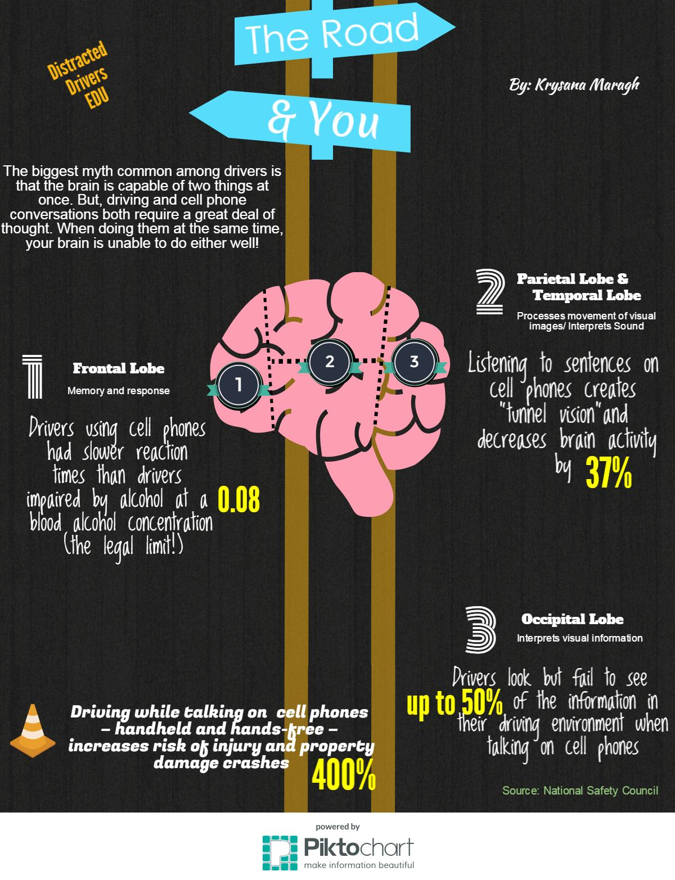
AAA. (2013, June 30). Think You Know All About Distracted Driving? Think Again, Says AAA | AAA NewsRoom. Retrieved April 27, 2015, from http://newsroom.aaa.com/2013/06/think-you-know- all-about-distracted-driving-think-again-says-aaa/
AAA. (2013, June 10). Cognitive Distraction: Something to Think About. Retrieved April 27, 2015, from http://newsroom.aaa.com/wp-content/uploads/2013/06/Cognitive-Distraction_AAAFTS- Research-Compendium.pdf
Center for Disease Control and Prevention (CDC). (2014, October 10). Distracted Driving. Retrieved April 27, 2015, from http://www.cdc.gov/motorvehiclesafety/distracted_driving /
Center for Neuro Skills (CNS). (1999, January 1). Parietal Lobes. Retrieved April 27, 2015, from http://www.neuroskills.com/brain-injury/parietal-lobes.php
Cheour, M. (2011, August 10). Parts of the Brain Used While Driving. Retrieved April 27, 2015, from http://www.livestrong.com/article/181361-parts-of-the-brain-used-while-driving/
Insurance Institute for Highway Safety. (2013, January 1). General statistics. Retrieved April 20, 2015, from http://www.iihs.org/iihs/topics/t/general-statistics/fatalityfacts/overview-of- fatality-facts
Locher, J., & Mortiz, O. (2009, July 19). Eating while driving causes 80% of all car accidents, study shows. Retrieved April 27, 2015, from http://www.nydailynews.com/new-york/eating-driving-80- car-accidents-study-shows-article-1.427796
National Conference of State Legislatures (NCSL). (2015, March 11). Distract. Retrieved April 27, 2015, from http://www.ncsl.org/research/transportation/spotlight-distracted-driving.aspx
National Highway Traffic Safety Administration (NHSTA). (2002, January 1). NATIONAL SURVEY OF DISTRACTED AND DROWSY DRIVING ATTITUDES AND BEHAVIORS: 2002. Retrieved April 27, 2015, from http://www.nhtsa.gov/people/injury/drowsy_driving1/survey-distractive03/summary.htm
National Safety Council (NSC). (n.d.). Safety on the Road. Retrieved April 20, 2015, from http://www.nsc.org/Pages/nsc-on-the-road.aspx
Telis, G. (2010, April 15). Multitasking Splits the Brain. Retrieved April 27, 2015, from http://news.sciencemag.org/2010/04/multitasking-splits-brain
U.S. Department of Trasportation (DOT). (2013, January 31). Distracted Driving Campaign. Retrieved April 27, 2015, from http://www.dot.gov/mission/performance/distracted-driving- campaign
U.S. Department of Transportation (DOT). Distracted Driving. (n.d.). Retrieved April 27, 2015, from http://www.distraction.gov/

